**1.Fabric Sales Per Year Per Month**

SELECT T.fabric_id, f.fabric_name, T.total_price, T.month, T.year

FROM

(

select pfm.fabric_id,

DATE_PART(month, transaction_date) as month,

DATE_PART(year, transaction_date) as year,

SUM(t.price) as total_price

from transactions t

join articles a on t.article_id = a.article_id

join product_fabric_map pfm on pfm.product_code = a.product_code

join fabric f on f.fabric_id = pfm.fabric_id

group by pfm.fabric_id, DATE_PART(month, transaction_date), DATE_PART(year, transaction_date)

) as T

JOIN fabric f on f.fabric_id = T.fabric_id

order by T.year, T.month ASC;

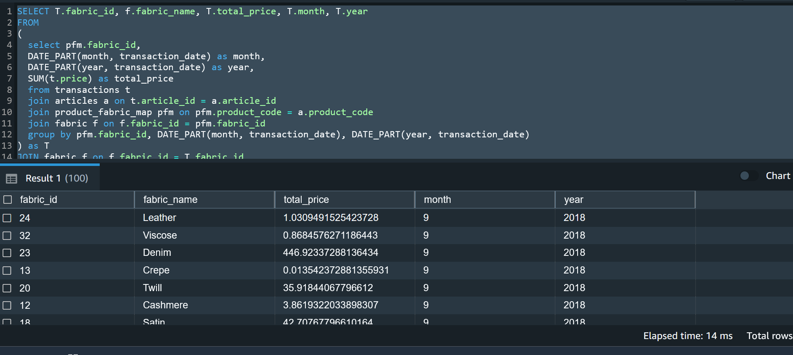

**2.Overall most sold fabric with total sales**

SELECT T.fabric_id, f.fabric_name, T.total_price

FROM

(

select pfm.fabric_id, SUM(t.price) as total_price

from transactions t

join articles a on t.article_id = a.article_id

join product_fabric_map pfm on pfm.product_code = a.product_code

join fabric f on f.fabric_id = pfm.fabric_id

group by pfm.fabric_id

) as T

JOIN fabric f on f.fabric_id = T.fabric_id

order by T.total_price DESC;

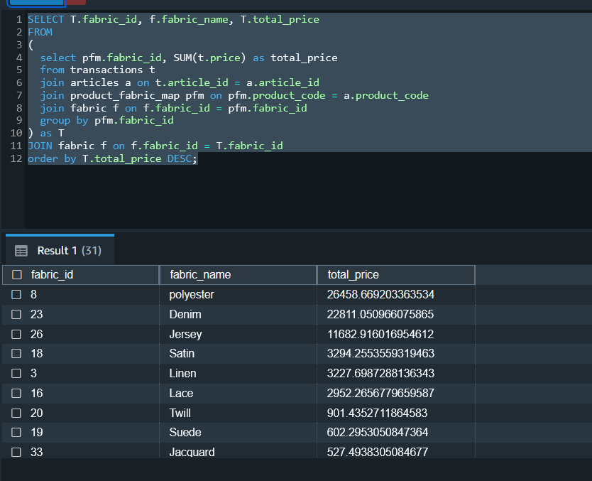

**3.Most sold fabric with total sales Per Year Per Month**

SELECT S.fabric_id, f.fabric_name, S.month, S.year, S.total_price

FROM (

select T.fabric_id, T.month, T.year, T.total_price,

MAX(T.total_price) over (partition by T.month, T.year) as max_sale

from

(

select pfm.fabric_id,

DATE_PART(month, transaction_date) as month,

DATE_PART(year, transaction_date) as year,

SUM(t.price) as total_price

from transactions t

join articles a on t.article_id = a.article_id

join product_fabric_map pfm on pfm.product_code = a.product_code

join fabric f on f.fabric_id = pfm.fabric_id

group by pfm.fabric_id, DATE_PART(month, transaction_date), DATE_PART(year, transaction_date)

) AS T

) AS S

JOIN fabric f on f.fabric_id = S.fabric_id

WHERE S.total_price = S.max_sale

order by S.year, S.month;

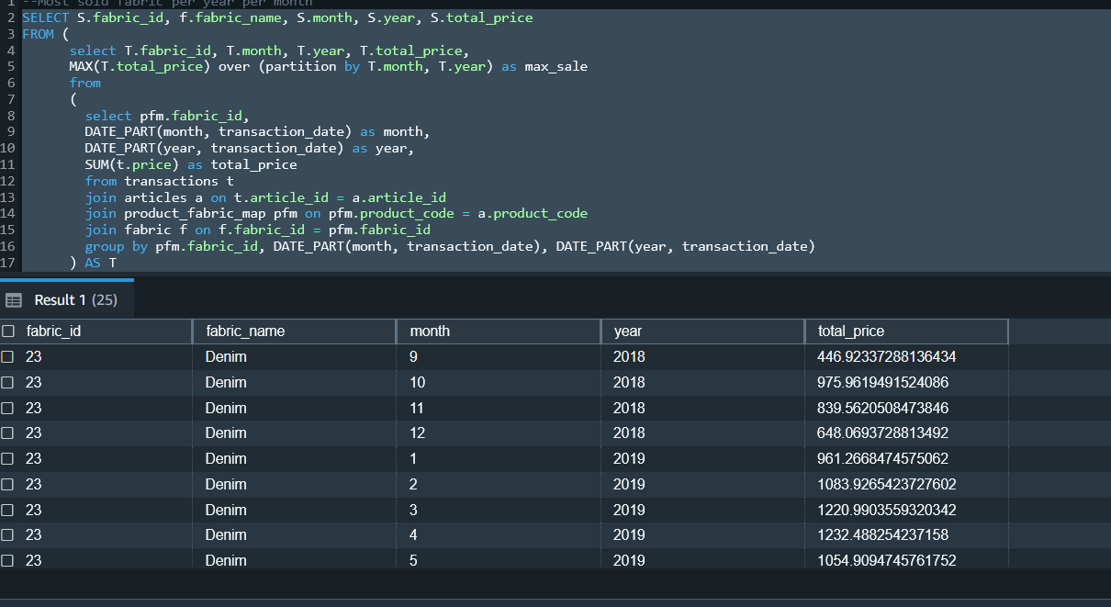

**4. List the number of transactions that happened in each quarter of all the years in order of minimum transactions. Excluding 2018, since it had data for only 4th quarter, we can see that sales were least in 2020 first and third quarter.**

select T.year, T.quarter, min(T.number_of_transactions) as MINIMUM_TRANS_CNT

from

(select extract(YEAR from transaction_date) as year,

extract(QUARTER from transaction_date) as quarter,

count(price) as number_of_transactions

from transactions

group by extract(YEAR from transaction_date),extract(QUARTER from transaction_date)

order by number_of_transactions, extract(YEAR from transaction_date), extract(QUARTER from transaction_date)

) T

group by T.year,T.quarter

order by MINIMUM_TRANS_CNT;

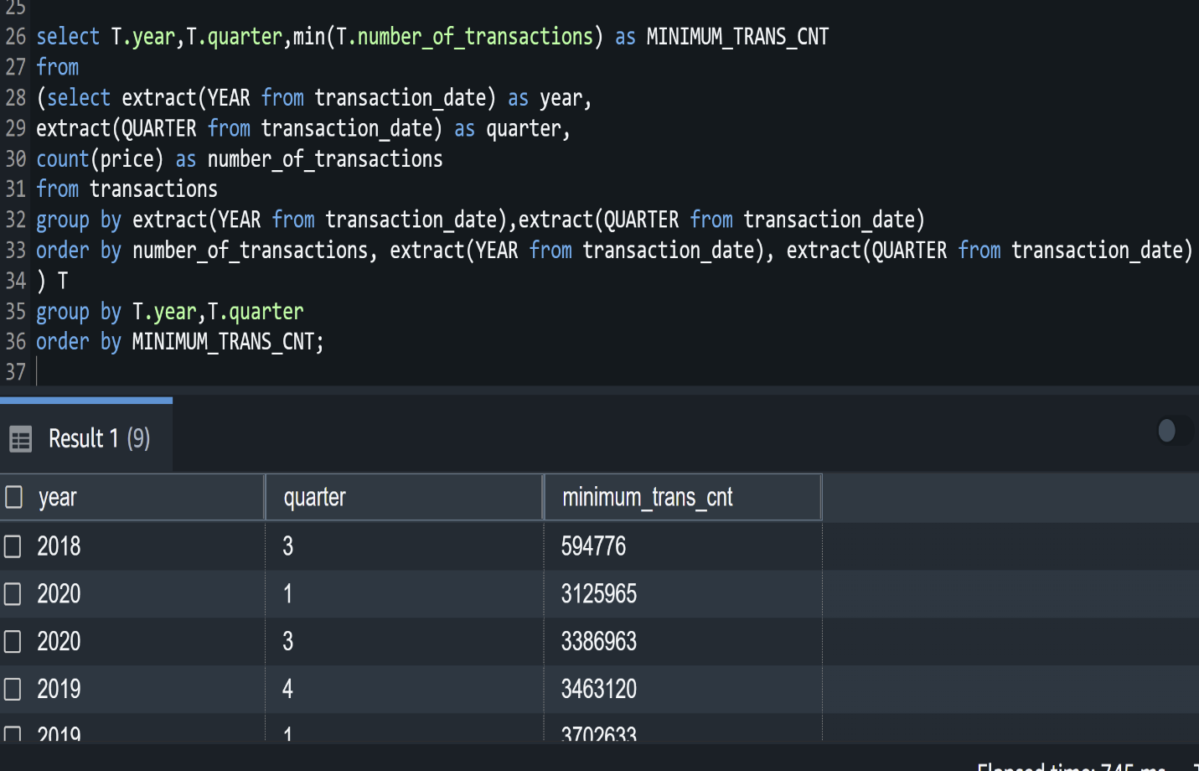

**5. List Per day transaction running amount per product type for year 2020.**

select distinct(t.transaction_date) , pt.type_name,

sum(t.price) over (PARTITION BY p.prod_name ORDER BY t.transaction_date ROWS BETWEEN UNBOUNDED PRECEDING AND CURRENT ROW) as transaction_runnin_total

from transactions t,product p,product_color_map pcm,

product_type pt,product_group pg

where t.article_id=pcm.article_id and pcm.product_code=p.product_code and

pt.product_group_id=pg.product_group_id and p.product_type_id=pt.product_type_id

and t.transaction_date > '2020-01-01' and t.transaction_date <= '2020-12-31'

ORDER BY p.prod_name;

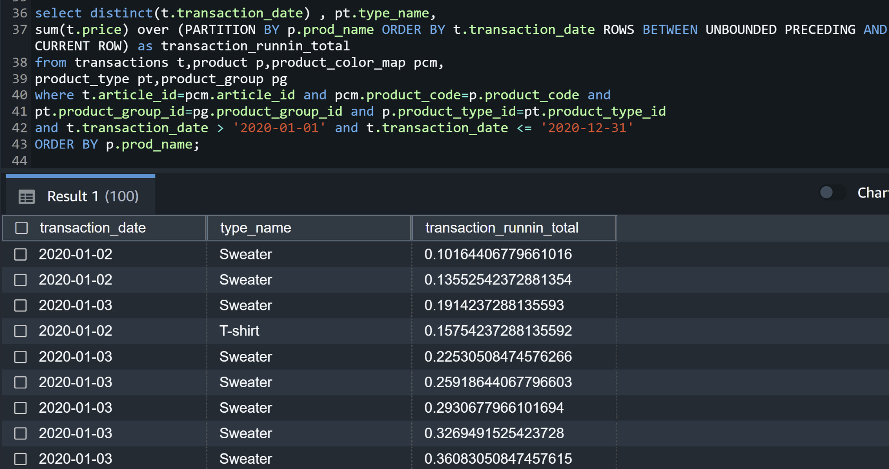

**6. List the first quarter of 2020 with daily sum price and daily price difference**.

select t.transaction_date , sum(t.price) as daily_sum_price,

(sum(t.price) - lag(sum(t.price)) over ( order by t.transaction_date))

as daily_difference

from transactions t,product p,product_color_map pcm,

product_type pt,product_group pg

where t.article_id=pcm.article_id and pcm.product_code=p.product_code and

pt.product_group_id=pg.product_group_id and p.product_type_id=pt.product_type_id

and t.transaction_date > '2020-01-01' and t.transaction_date <= '2020-03-31'

GROUP BY t.transaction_date , EXTRACT(QUARTER from t.transaction_date) asc;

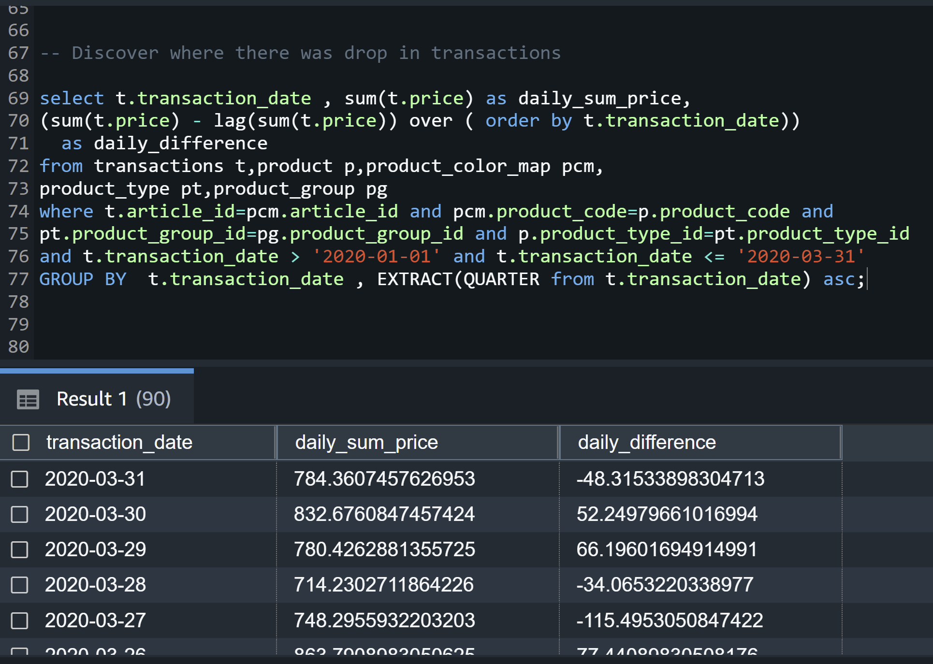

**7. ROLL UP for average age of customer along with their skin condition. ROLL UP and CUBE are not supported in AWS REDSHIFT. So, we use the alternative here.**

**select customer_id, skin_condition_level, avg(age) as total_age**

**from customer**

**group by customer_id, skin_condition_level**

**union all**

**select customer_id, null as skin_cond, avg(age) as total_age**

**from customer**

**group by customer_id**

**union all**

**select null, null, avg(age) as total_age**

**from customer**

**order by 1,2**

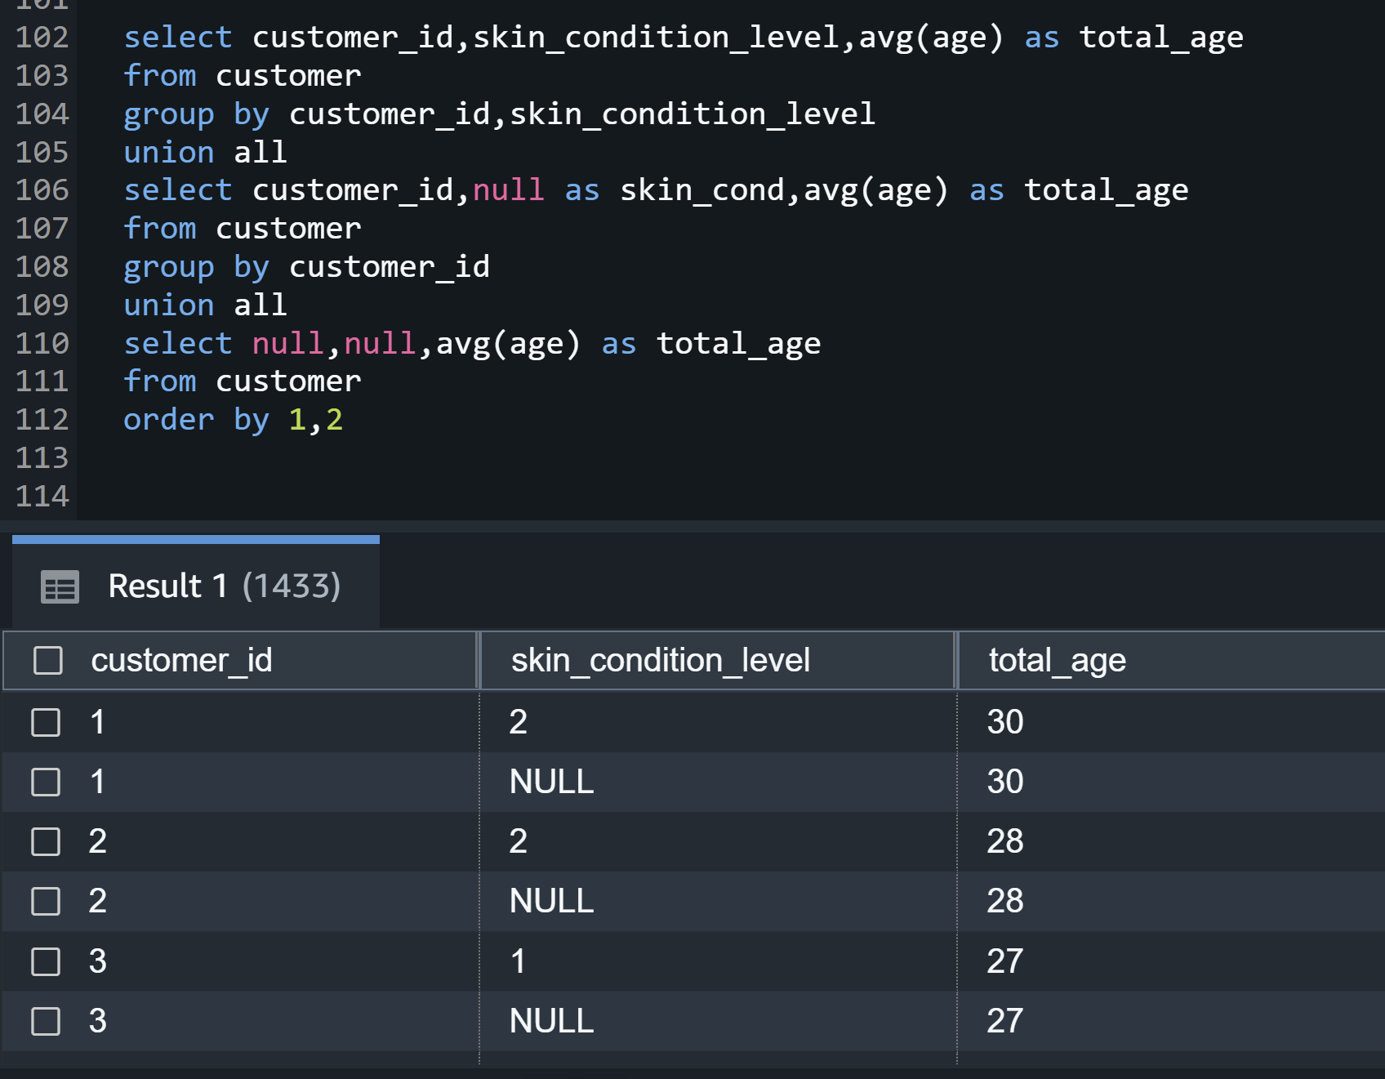

**8. Customer sales for the year 2019 and 2020. Sales for 2020 has declined for all customers, most probably due to the pandemic.**

**select t.customer_id, avg(t.price) as total_sales_per_customer,**

**SUM(CASE when t.transaction_date >= '2019-01-01' and t.transaction_date < '2020-01-01' THEN t.price else 0 END) as cust_sale_2019,**

**SUM(CASE when t.transaction_date >= '2020-01-01' and t.transaction_date < '2021-01-01' THEN t.price else 0 END) as cust_sale_2020**

**from transactions t**

**Group by t.customer_id order by total_sales_per_customer desc;**

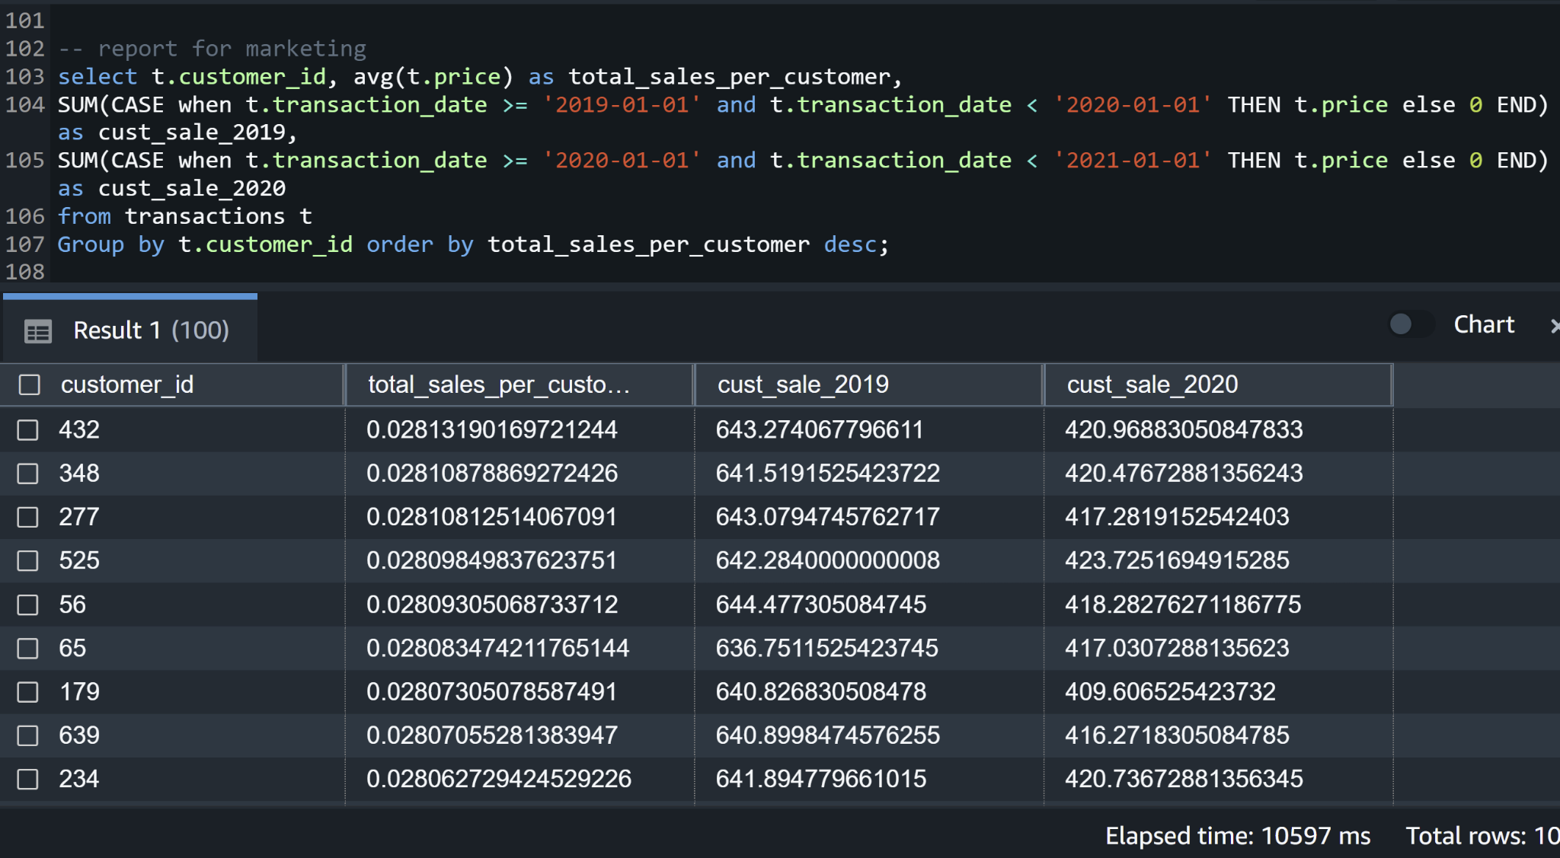

**9. Find the cumulative distribution of customer transactions**

select EXTRACT(MONTH from t.transaction_date) as Month, t.customer_id, t.price ,

cume_dist() OVER(

PARTITION BY EXTRACT(MONTH from t.transaction_date)

ORDER BY t.price

) as distribution_price

from transactions t

where t.transaction_date between '2019-01-01' AND '2020-08-31'

order by EXTRACT(MONTH from t.transaction_date) desc;

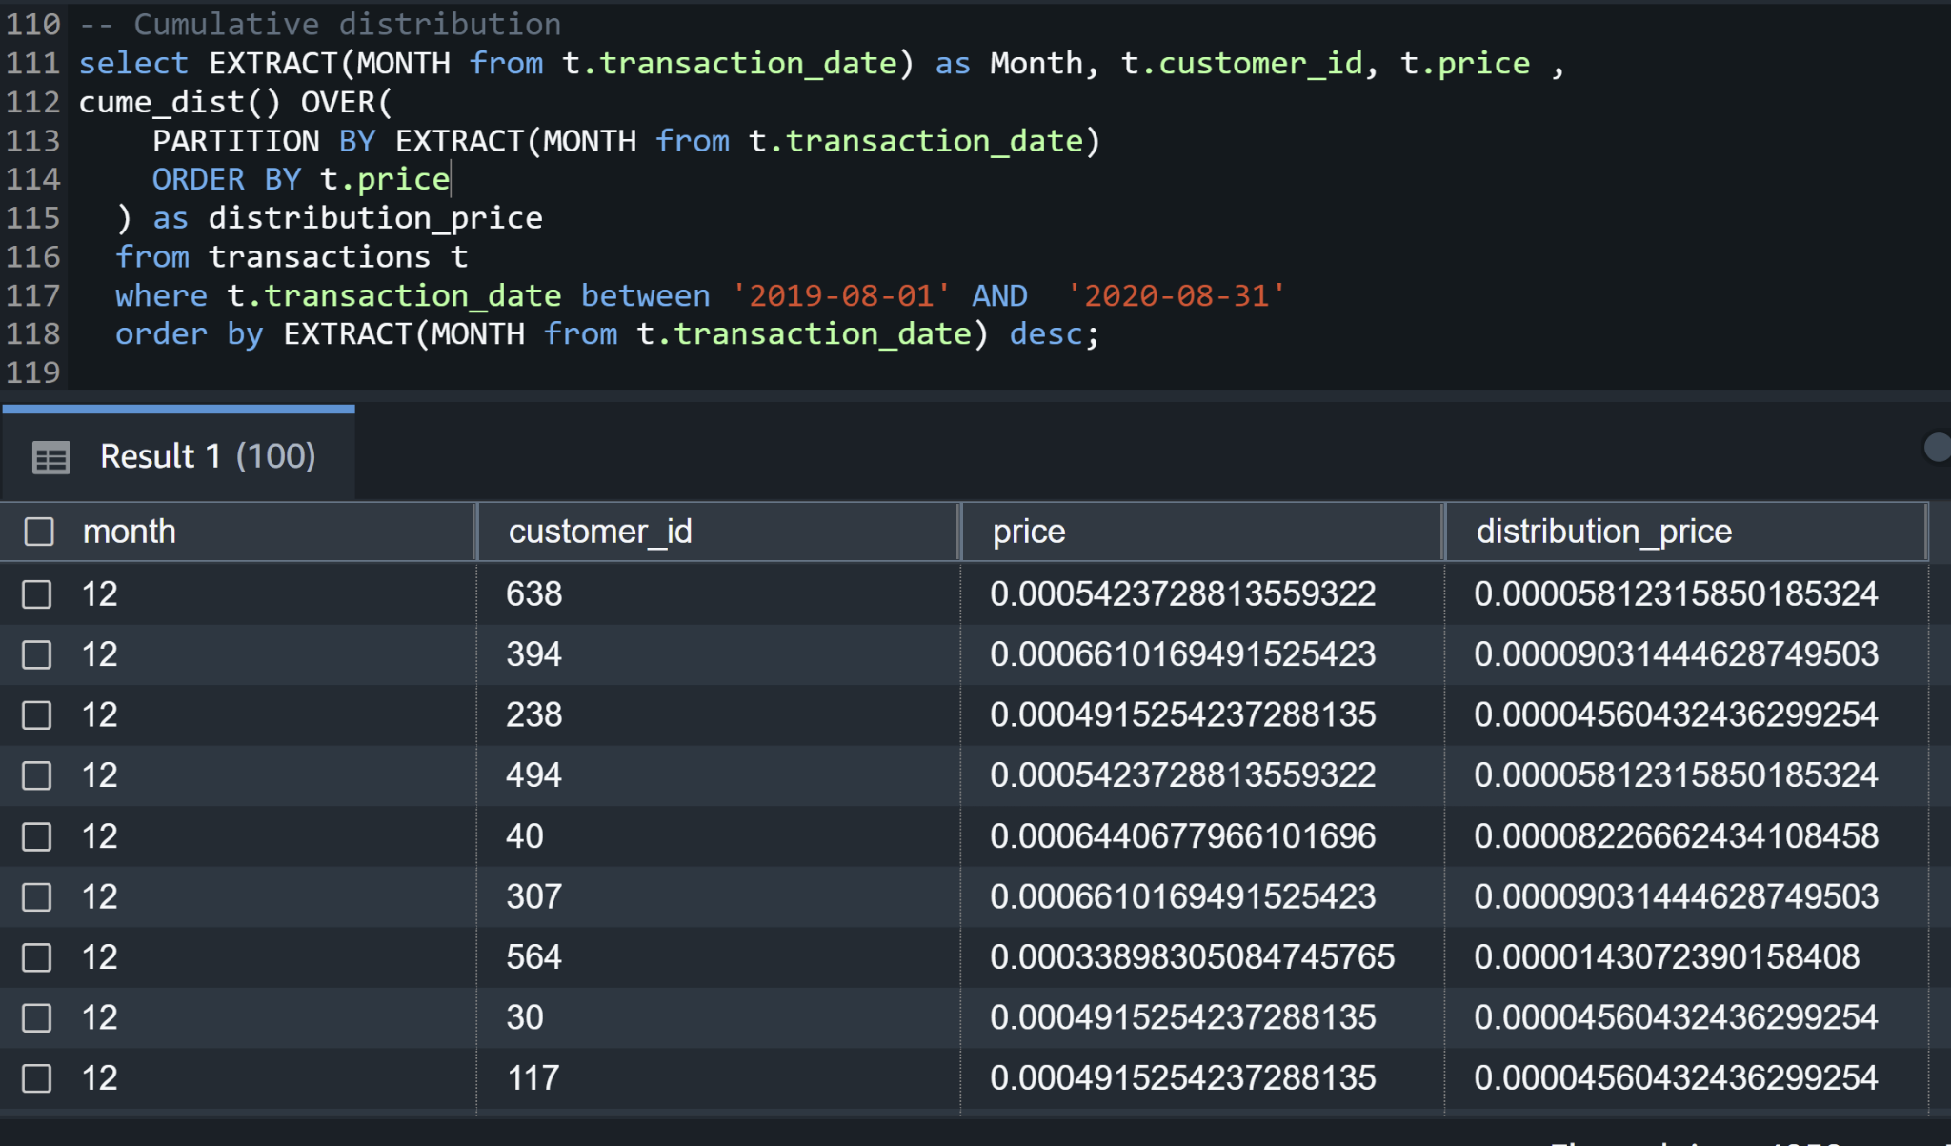

**10. Average pricing per product group.**

select distinct pg.group_name,avg(price) over (partition by pt.product_group_id) AvgPrice

from transactions t,product p,product_color_map pcm,

product_type pt,product_group pg

where t.article_id=pcm.article_id and pcm.product_code=p.product_code and

pt.product_group_id=pg.product_group_id and p.product_type_id=pt.product_type_id;

